CHAN Hei Tung
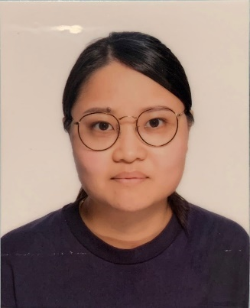
Phone +852 6229-6908
E-mail tungs719@yahoo.com.hk

Health Worker

Experience

2019-2021 Part-time Health worker Sister Randi's Home for The Elderly
- Provide a safe and therapeutic environment in promoting the well-being of clients.
- Implement medical and health measures and evaluate related effects.

2018-2019 Contract Health worker

The salvation army po lam residence for senior citizens
- Provide a safe and therapeutic environment in promoting the well-being of clients.
- Implement medical and health measures and evaluate related effects.
- Manage and distribute medicines to clients.
- Provide wound care and dressing services to those in need.
- Provide basic first aid to residents when there is an accident or emergency.
- Supervise the daily work of Personal Care Worker.
- Contact the hospital and relatives when needed to discuss the client's care plan.

2016-2018 Holistic care practiontioner/ Health worker

Tung wah group of hopistal blissful villa

- Provide a safe and therapeutic environment in promoting the well-being of clients.
- Implement medical and health measures and evaluate related effects.
- Administer and distribute medicines to clients.
- Provide wound care and dressing services to those in need.
- Provide basic first aid to residents when there is an accident or emergency.
- Supervise the daily work of Personal Care Worker.
- Contact the hospital and relatives when needed to discuss the client's care plan.

2014-2015 Personal Care worker

Hong Kong Chinese Women's Club Madam wong chan sook ying memorial care & attention home for the aged

- Provide personal hygiene needs, including bathing and using the restroom.
- Transport and physical move clients into and out of bed and other areas.
- Perform tasks assigned by Nurses.

Education

2021-2023 Tung Wah collage
- Higher Diploma in Nursing

2019-2021 The Open University of Hong Kong

Li Ka Shing School of Professional and Continuing Education

- Higher Diploma in Health Care
- Dean’s List for 2019/2020
- Complete the course MGT4904EW-Gaining the Most from Work-integrated Learning (2019/2020) and granted a certificate by ASDAN (Award Scheme Development and Accreditation Network).

2014-2016 The Open University of Hong Kong
- Diploma in Health Studies (Community Health Care)
- Jockey Club Community Healthcare Education Scholarship (2014/2015)
- Jockey Club Community Healthcare Education Scholarship (2015/2016)

CERTIFICATE

2020 hong kong St.john ambulunce assosiation
FIRST-AID CERTIFICATE

2014 KCRA COMMUNITY EDUCATION ENHANCEMENT CENTRE LIMITED
PERSONAL CARE WORKER TRAINING COURSE

2012 THE HONG KONG CONDFEDERATION OF TRADE UNIONS
MODULE CERTIFICATE IN BASIC CARING SKILLS IN PHYSIOTHERAPY

2010 HONG KONG RED CROSS
CERTIFICATE IN CARE-RELATED SUPPORT WORKER TRAINING

LAUGUAGE Cantonese ★ ★ ★ ★ ★
English ★ ★ ★ ☆ ☆
Mandarin ★ ★ ★ ★ ☆
Hakka ★ ★ ★ ★ ☆

SKILLS Microsoft Office, Google Drive, Chinese & English Typing, Latte Art.

INTERESTS Travel, Photography, Cycling, Hiking, Coffee & Food

